|  |
| --- |
| 1. **Implementation of bootstrap into Laravel** |

*Download “bootstrap.min.css” and “bootstrap.bundle.min.js” file from https://getbootstrap.com/docs/5.1/getting-started/download.*

**Routes**

**web.php**

<?php

use Illuminate\Support\Facades\Route;

Route::get('/', function () {

return view('index');

});

?>

**View**

**headfoot.blade.php**

<!DOCTYPE html>

<html lang="en">

<head>

<meta charset="utf-8">

<meta name="viewport" content="width=device-width, initial-scale=1, shrink-to-fit=no">

<title>Xtreme Fitness</title>

<link rel="icon" type = "image/png" href="<?php echo config('app.url')."/GYM/resources/"; ?>img/favicon.png">

<link rel="stylesheet" type="text/css" href="<?php echo config('app.url')."/GYM/resources/"; ?>css/bootstrap.min.css">

<link rel="stylesheet" type="text/css" href="<?php echo config('app.url')."/GYM/resources/"; ?>css/style.css">

<script type="text/javascript" src="<?php echo config('app.url')."/GYM/resources/"; ?>js/javas.js"></script>

<script type="text/javascript" src="<?php echo config('app.url')."/GYM/resources/"; ?>js/jquery-3.3.1.min.js"></script>

<script type="text/javascript" src="<?php echo config('app.url')."/GYM/resources/"; ?>js/bootstrap.bundle.min.js"></script>

</head>

<body class="img-fulid">

<nav class="navbar navbar-expand-lg navbar-dark bg-secondary">

<a class="navbar-brand mb-0 h1" href="/">Xtreme Fitness </a>

<button class="navbar-toggler" type="button" data-toggle="collapse" data-target="#navbarSupportedContent" aria-controls="navbarSupportedContent" aria-expanded="false" aria-label="Toggle navigation">

<span class="navbar-toggler-icon"></span>

</button>

<div class="collapse navbar-collapse" id="navbarSupportedContent">

<ul class="navbar-nav mr-auto">

<li class="nav-item">

<a class="nav-link mb-0 h5" href="/training">Training</a>

</li>

<li class="nav-item">

<a class="nav-link mb-0 h5" href="/yoga">Yoga</a>

</li>

<li class="nav-item">

<a class="nav-link mb-0 h5" href="/diet">Diet</a>

</li>

<li class="nav-item">

<a class="nav-link mb-0 h5" href="/about">About</a>

</li>

<li class="nav-item">

<a class="nav-link mb-0 h5" href="/contact">Contact</a>

</li>

</ul>

<ul class="navbar-nav navbar-right">

<li class="nav-item">

<a href="signup" class="nav-link mb-0 h5 ">Sign Up</a>

</li>

<li class="nav-item">

<a href="/login" class="nav-link mb-0 h5"> Login</a>

</li>

</ul>

</div>

</nav>

@yield("page-cont")

<footer class="page-footer font-small fixed-bottom navbar-dark bg-secondary">

<div class="footer-copyright text-center py-2">© 2022 Copyright: Akhil P Thomas

</div>

</footer>

</body>

</html>

**index.blade.php**

@extends("layouts.header")

@section("page-cont")

<br>

<div>

<a href="/signup">

<marquee id="move" direction="left" scrollamount="10">

<h2 onmouseover="mouseOver()" onmouseout="mouseOut()"><a id="mar" href="/signup" style="color : red" >Join Gym Now</a></h2>

</marquee>

</a>

</div>

<div id = "intro" class="container">

<h3><span style="font-weight: 900; color: White">Xtreme Fitness</span></h3><br>

<p><span style="font-weight: 600; color: white">Xtreme Fitness is a gym that provide facility to exercise using machines, weights, and other equipment.

Here people can do physical exercise and get fit. we have certified personal trainers to train members of the gym.</span>

</p>

</div>

<!-- image -->

|<br>

<div class="container">

<div class="row">

<div class="col-md-4">

<div class="thumbnail">

<a href="/training">

<img src="<?php echo config('app.url')."/GYM/resources/"; ?>img/Training.jpg" alt="Training" style="width:100%; height:80%;">

<div class="caption">

<p style="font-weight: 600; color: white; text-align:center">Train at Gym</p>

</div>

</a>

</div>

</div>

<div class="col-md-4">

<div class="thumbnail">

<a href="/yoga">

<img src="<?php echo config('app.url')."/GYM/resources/"; ?>img/yoga.jpg"alt="Yoga" style="width:100%; height:80%;">

<div class="caption">

<p style="font-weight: 600; color: white; text-align:center">Do yoga at Gym</p>

</div>

</a>

</div>

</div>

<div class="col-md-4">

<div class="thumbnail">

<a href="/diet" >

<img src="<?php echo config('app.url')."/GYM/resources/"; ?>img/diet.jpg" alt="Diet" style="width:100%">

<div class="caption">

<p style="font-weight: 600; color: white; text-align:center"> Have a healthy diet</p>

</div>

</a>

</div>

</div>

</div>

</div>

<!-- <div>

<ul>

<li style="width: 90%">

<img class="img-fluid img-thumbnail rounded float-left" style="width: 30%" src="<?php echo config('app.url')."/GYM/resources/"; ?>img/Training.jpg">

<img class="img-fluid img-thumbnail rounded mx-auto d-block" style="width: 30%" src="<?php echo config('app.url')."/GYM/resources/"; ?>img/Yoga.jpg">

<img class="img-fluid img-thumbnail rounded float-right" style="width: 30%" src="<?php echo config('app.url')."/GYM/resources/"; ?>img/Diet.jpg">

</li>

</ul>

</div> -->

@endsection

**Output**

1)Full screen view

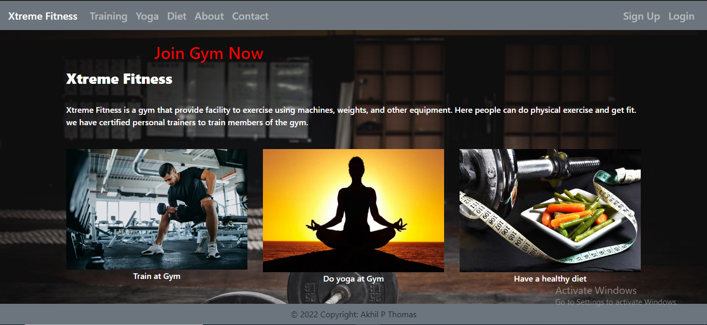

2) Minimized view

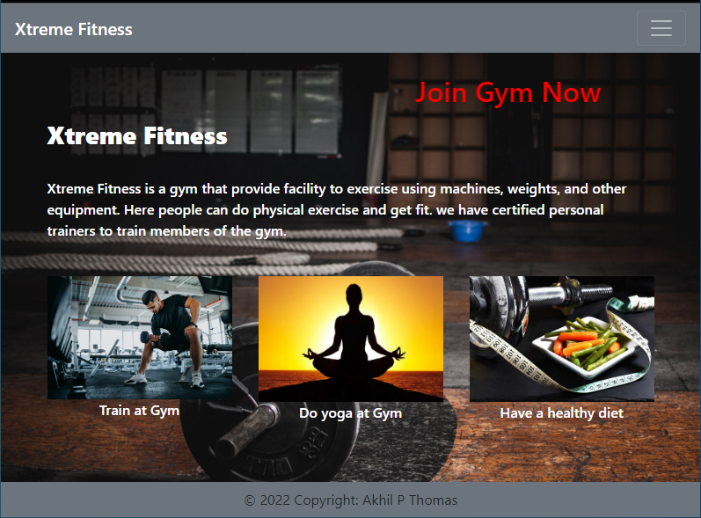

3) Mobile view

